INTERNATIONALLY ACCLAIMED AUTHOR DAVID ROHL
DEBUTS U.S. RELEASE OF

EXODUS: MYTH OR HISTORY?

BRITISH EGYPTOLOGIST AND HISTORIAN INVITES AMERICA TO EXAMINE IN DETAIL THE EVIDENCE FOR THE BIBLICAL EXODUS IN NEW BOOK SLATED TO RELEASE OCT. 8 THROUGH THINKING MAN MEDIA

"When it comes to exploring, David Rohl makes Indiana Jones look like an under-achiever... Rohl is Britain's highest profile Egyptologist."
- Daily Express

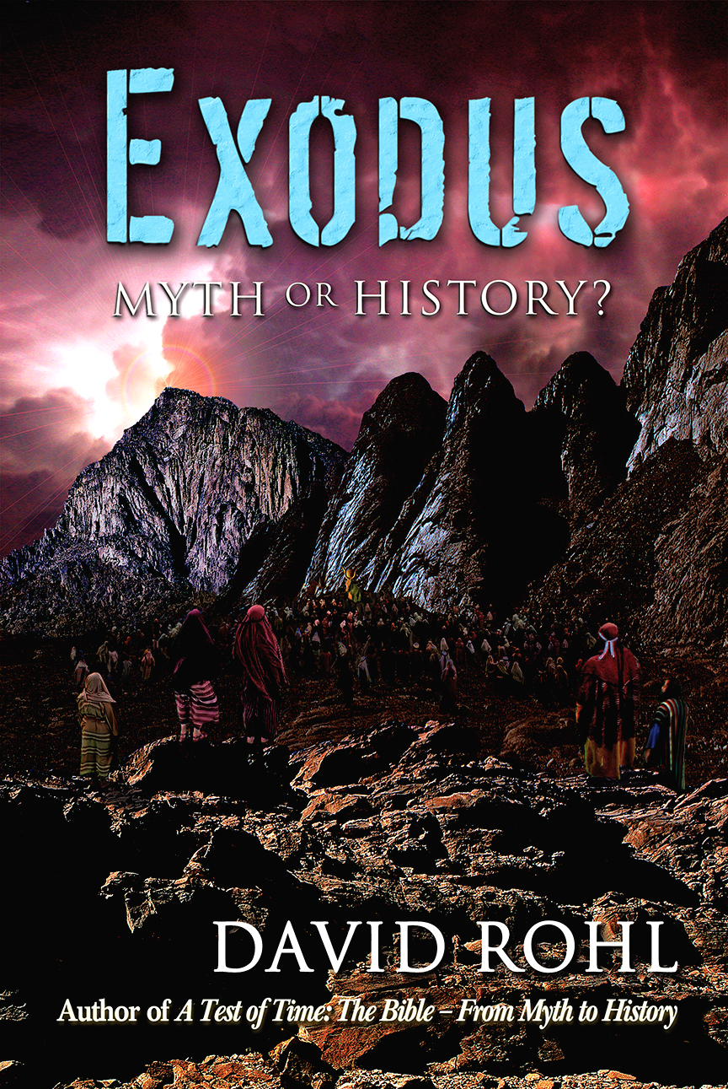
LOSANGELES, Calif. (Oct. 7, 2015)– British Egyptologist and best-selling author David Rohl will bring his newest book, “EXODUS: Myth or History?” to U.S. audiences onOct. 8through Thinking Man Media.Rohl’s previous best-selling books (“Pharaohs and Kings” and“Legend: The Genesis of Civilisation”) have been published throughout the world and are currently available in 12 different languages. Now, with the U.S. launch of his latest title,Rohlinvites America to examine in detail the evidence forthe Exodus. “EXODUS: Myth or History?”accompanies the wildly successful documentary Patterns of Evidence: The Exodus(Thinking Man Films)in laying out archaeological and historical evidence for a new chronology of the biblical Exodus.

“Since the turn of the century, there has been a growing awareness of the heated debate raging within academia over the Old Testament—focusing on its value as a true or accurate record of Israelite history,” says Rohl. “The consensus among secular historians and archaeologists today is that the biblical narratives are essentially mythological – a ‘pious fiction’ created by the Judean priesthood sometime between the seventh and third centuries BC.”

After more than 30 years of archaeological research (in conjunction with his team of like-minded investigators), Rohlhas compiled his evidence into an in-depth written account revealing that archaeologists and historians have been looking in all the right places for signs of the Exodus, but in entirely the wrong time. “EXODUS: Myth or History?”uncovers the clear fact that the Exodus never happened in the reign of Ramesses the Great, as most scholars and all the Hollywood movies have insisted, but rather in a much earlier period – the Middle Bronze Age.

“Rohl’s real achievement is the way in which he has pieced the evidence together into a coherent, properly magnificent story, the first of all stories, for the first time,” reads a review in the Sunday Times. “Rohl packs more into this one book than most archaeologist-historians would attempt to set down in a lifetime.”

Containing 416 pages of text crammed with fascinating facts and argument, illustrated by 329 full-color photographs, maps, satellite images, plans and charts, “EXODUS: Myth or History?”solves the chronological conundrums of biblical history while igniting a revolution in Biblical Archaeology, which will transform how we think about the Old Testament and its epic narratives.At last, the true historical setting behind the scriptural account of the Israelite Sojourn in Egypt beginning with Joseph and Jacob, the Exodus under Moses, and the Conquest of the Promised Land by an Israelite army, led by Joshua, is uncovered in the bones and stones of the Bible lands.

“This is a book for those who want to examine the evidence in detail … but it is also an absorbing and captivating read,” says Timothy Mahoney, Filmmaker, Author and Thinking Man Media’s founder and CEO. “David’s previous best-selling books have been published throughout the world but his work is not so well known in the USA. All of that is about to change and we are excited to introduce American audiences to ‘EXODUS: Myth or History?’which is a true goldminefor those fascinated by the Biblical stories and the history of Ancient Egypt!”

For the latest news and updatesregarding “EXODUS: Myth or History?,” please visit:

Website: http://www.patternsofevidence.com
Blog: http://davidrohl.blogspot.com/2012/01/about-david-rohl.html
Facebook Page: https://www.facebook.com/exodusmythorhistory

EXODUS: Myth or History?
Street Date – Oct.8, 2015
ISBN-13: 978-0-9864310-2-9
Price: $29.95
Format: Hardcover
Page count: 416 Pages
Genre: Biblical Archaeology / Ancient Egypt / The Bible
Features: 416 pages of text combined with facts and argument, illustrated by 329 full-color photographs, maps, satellite images, plans and charts
Status - New Release available via Amazon (Thinking Man Media)- will hyperlink once it’s up and available on Amazon

About David Rohl
David Rohl is an Egyptologist, historian, and archaeologist specializing in the historical relationship between pharaonic Egypt and the Bible. He is also a television documentary presenter known principally for his internationally acclaimed series “Pharaohs and Kings” (1995) and “In Search of Eden” (2001), which have been seen by millions around the world, and for his best-selling book, “A Test of Time” (published in the USA as “Pharaohs and Kings: A Biblical Quest”).

About Thinking Man Media
Thinking Man Films and its publishing division, Thinking Man Media, are focused on creative development, production and distribution of engaging products for cinema, television, web and print.Thinking Man Films desires to gain a better understanding of significant and complex topics by exploring the world with those who are curious. The company is led by Timothy Mahoney.

For media inquiries, please contact:

Rogers & Cowan
Tracy Cole
office: 310-871-8349/cell: 615-568-2988
email: tcole@rogersandcowan.com

