Patterns of Evidence: The Exodus
Guide to Press Photography at: http://press.patternsofevidence.com

Captions shown here for each download available.

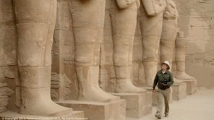

Filmmaker Timothy Mahoney searching for evidence in Karnak, Egypt

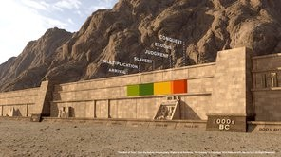

The Wall of Time showing six major steps of biblical history

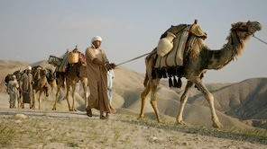

The Bible states Joseph was brought to Egypt and sold as a slave

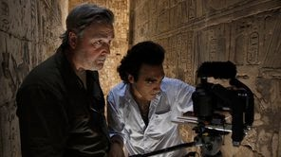

Timothy Mahoney filming with cameraman Ramy Romany

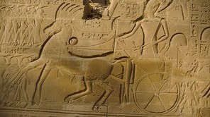

Egypt’s pharaohs displayed their power and glory on the walls of temples

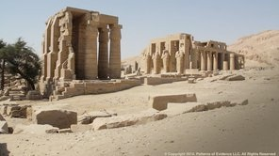

The mortuary temple of Ramesses II, who many consider the pharaoh of the Exodus

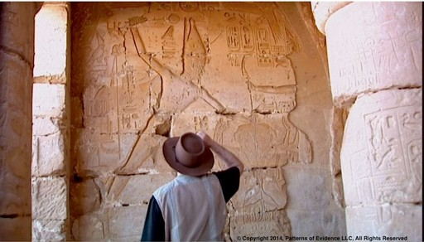

Egyptologist David Rohl has spent a lifetime studying the ancient civilization of Egypt

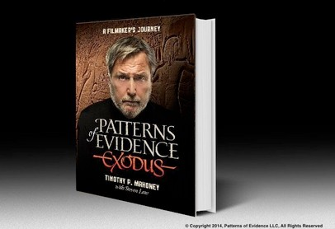

Timothy Mahoney’s new book chronicles the behind the scenes story of his 12-year investigation

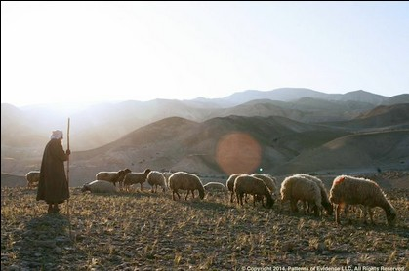

The Exodus story actually begins with the patriarch Abraham

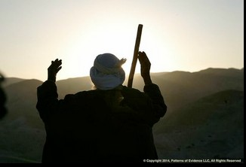

Three religions see Abraham as their patriarch

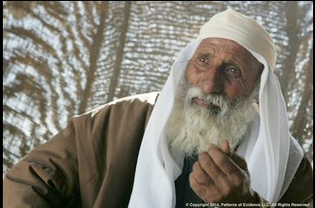

In Genesis 15 Abraham was told that his descendants would be strangers in a country not their own and enslaved

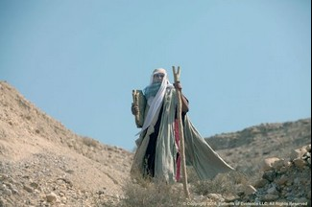

Exodus chapter 20 states that Moses was given commandments by God at Mt. Sinai

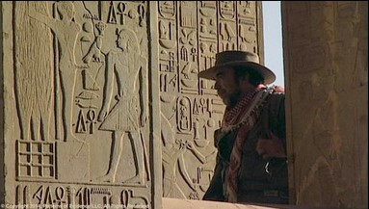

Egyptologist David Rohl is an agnostic. Yet he sees evidence for the Biblical story in Egypt.

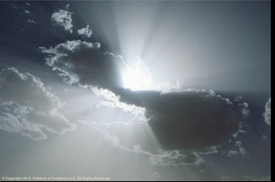

The biblical account claims that God acted in history

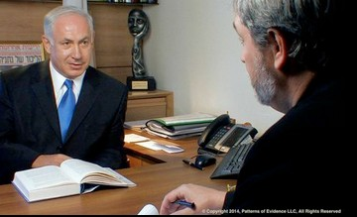

Israeli Prime Minister, Benjamin Netanyahu: “Moses was the greatest revolutionary of all time.”

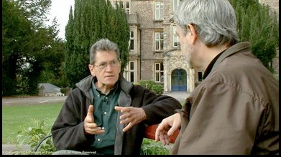

John Bimson, Professor at Trinity College, Bristol sees evidence of Semitic settlements in the Nile Delta

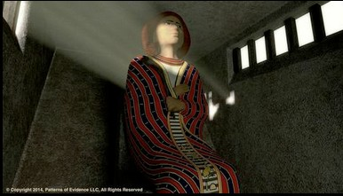

Why was a Semitic ruler (with a multicolored coat)
given an Egyptian pyramid tomb? Could this be Joseph?

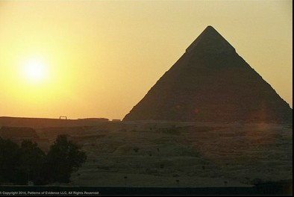

In the book of Exodus the Israelite slaves were delivered out of Egypt

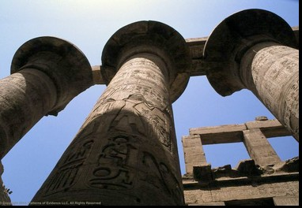

Egypt was one of the mightiest kingdoms of the ancient world

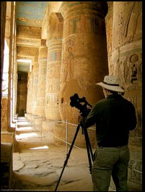

Timothy Mahoney investigating the links between Egypt and the Bible

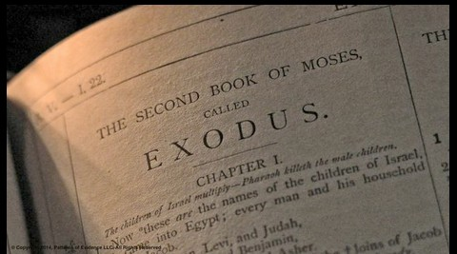

Tradition credits Moses as the author of the first five books of the Bible

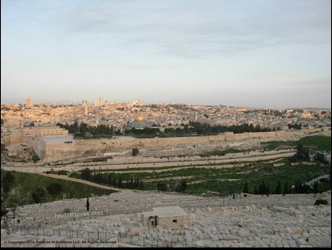

Jerusalem, the center of ancient Israel

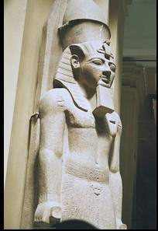

Was Ramesses II really the pharaoh of the Exodus?

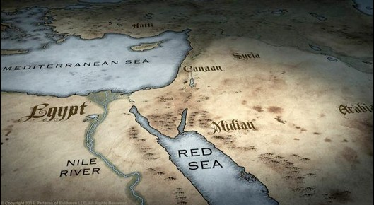
The ancient lands of the Exodus story

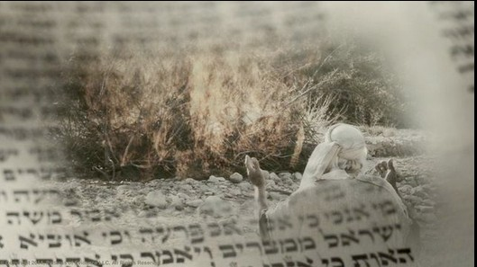

In Exodus chapter 3 God spoke with Moses from a burning bush

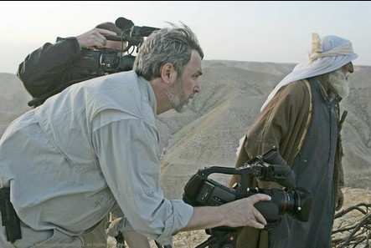

Director, Timothy Mahoney filming a reenactment of Abraham in Israel

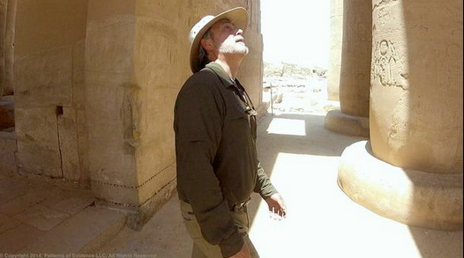

Timothy Mahoney searched for patterns of evidence throughout the Middle East

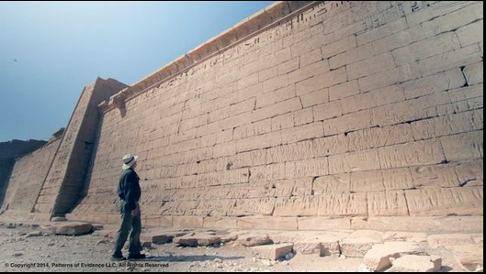

Filmmaker Timothy Mahoney investigating the stories of the Bible in Egypt

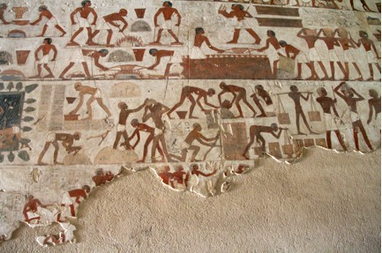

The tomb of Rekhmire showing Egyptians with Nubians and Semitic slaves

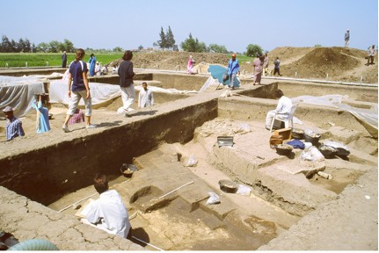

Archaeological dig site (Tell el-Dab’a) eastern Nile Delta, in the area that the Bible designates the Israelites lived

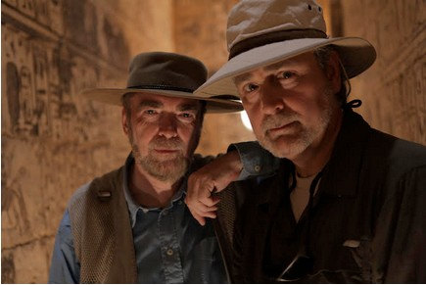

Egyptologist David Rohl and Timothy Mahoney uncovering clues from the Bible in Egypt's past

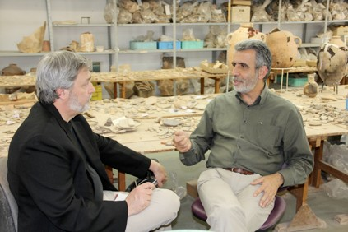

Israeli archaeologist Israel Finkelstein told Timothy Mahoney, “The Exodus did not happen as written in the Bible during the 13th century BC”

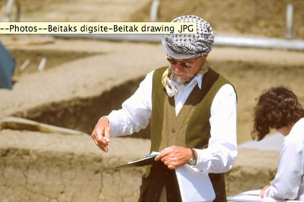

Austrian Egyptologist Manfred Bietak digging up an ancient city of Semites in the Nile Delta

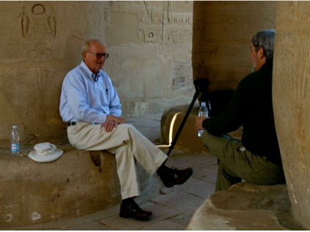

Egyptologist Kent Weeks, who rediscovered tomb KV5 told Mahoney, “Ramesses II as the pharaoh of the Exodus, how can we prove that?

If you have any questions about these images or require any assistance, Please contact:

Thinking Man Media Peter Windahl, Producer

6900 West Lake Street Minneapolis, MN 55426
952-915-9502 x21

